Assignment 1

Module: EEN 1037 Web Application Development (20713)

Assignment: Assignment 1 (HTML, CSS)

Student Name: Ziaul Haque Rafi

Student Number: A00096932

Project Title
Vault Bank – Client-Side Web Application

Project Overview
Vault Bank is a client-side static web application developed to demonstrate the use of HTML, CSS and Bootstrap in designing a modern, user-friendly online banking web interface. The application represents an online banking platform where users can view accounts, transactions, loans, and perform basic actions such as registration and money transfer through static interfaces.
The project was intentionally designed as a scalable banking system, allowing future enhancement with server-side technologies and databases in later assignments, as required by the module

UI Design
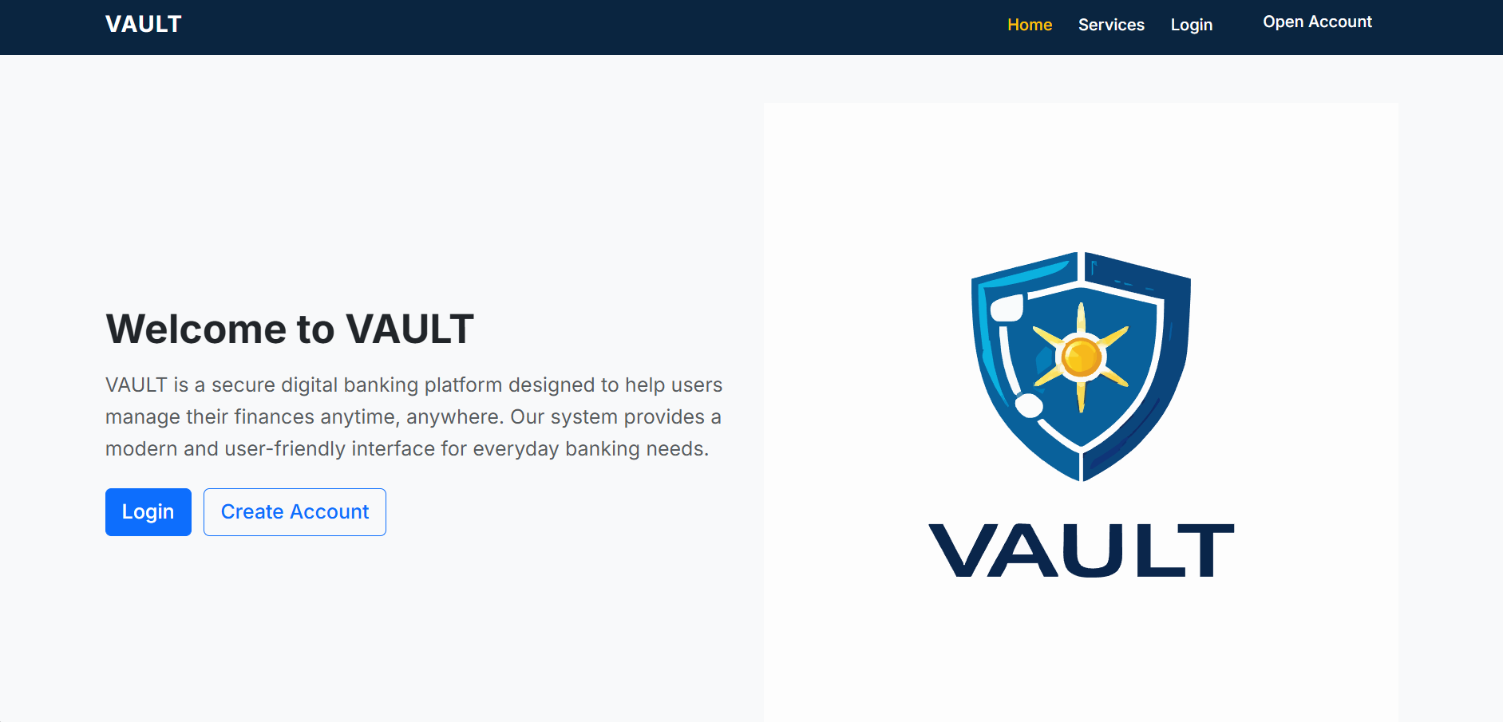. 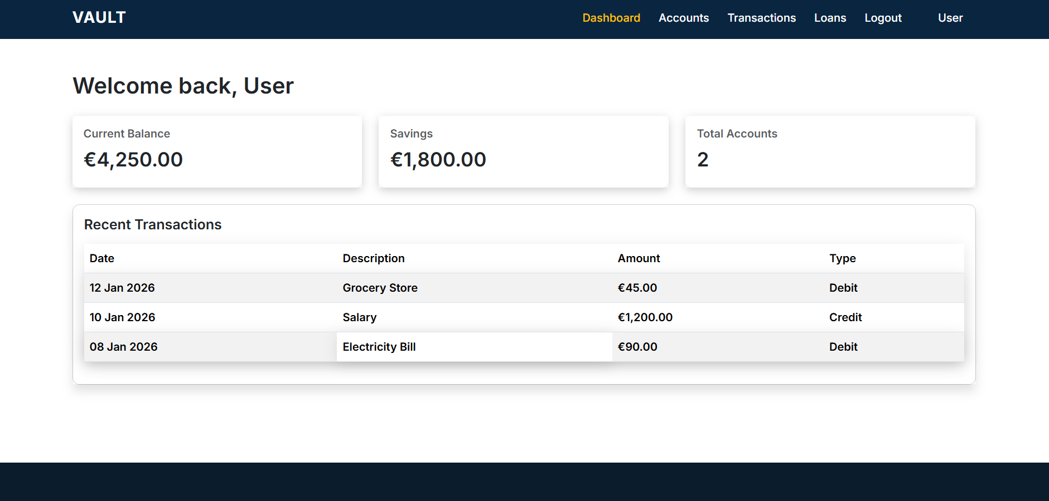 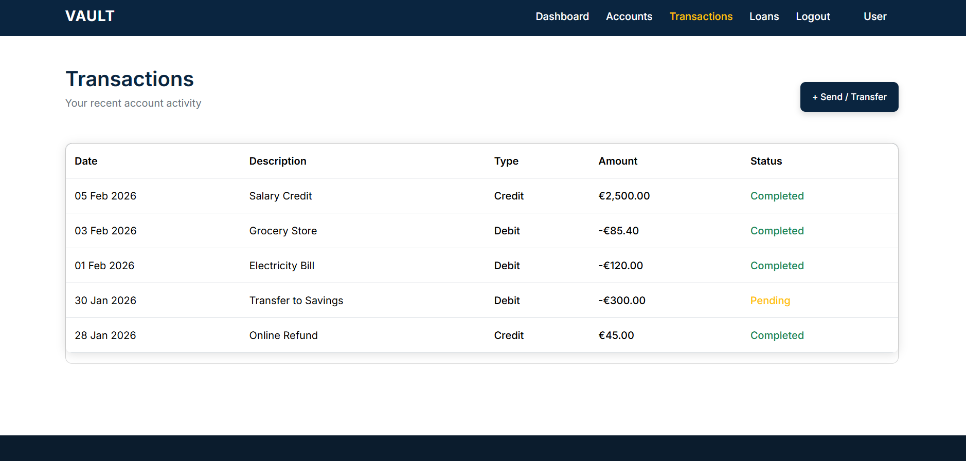
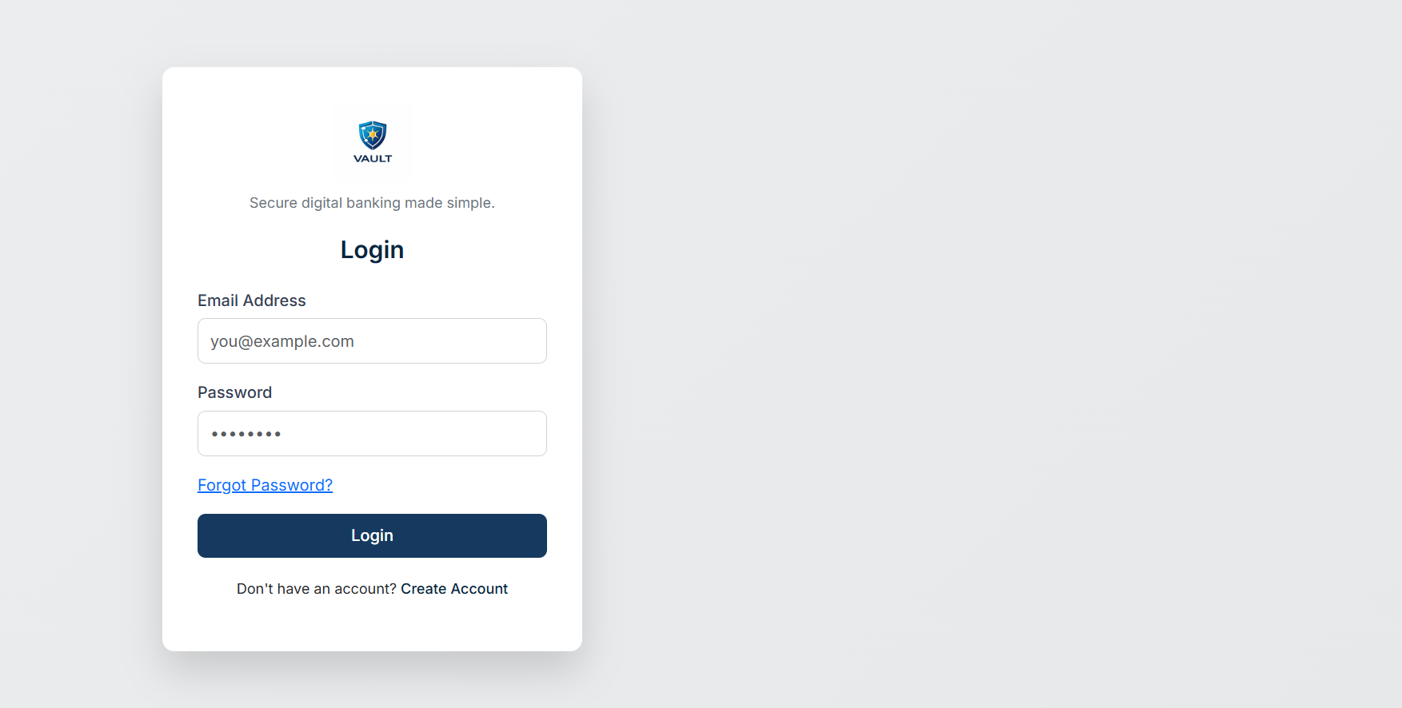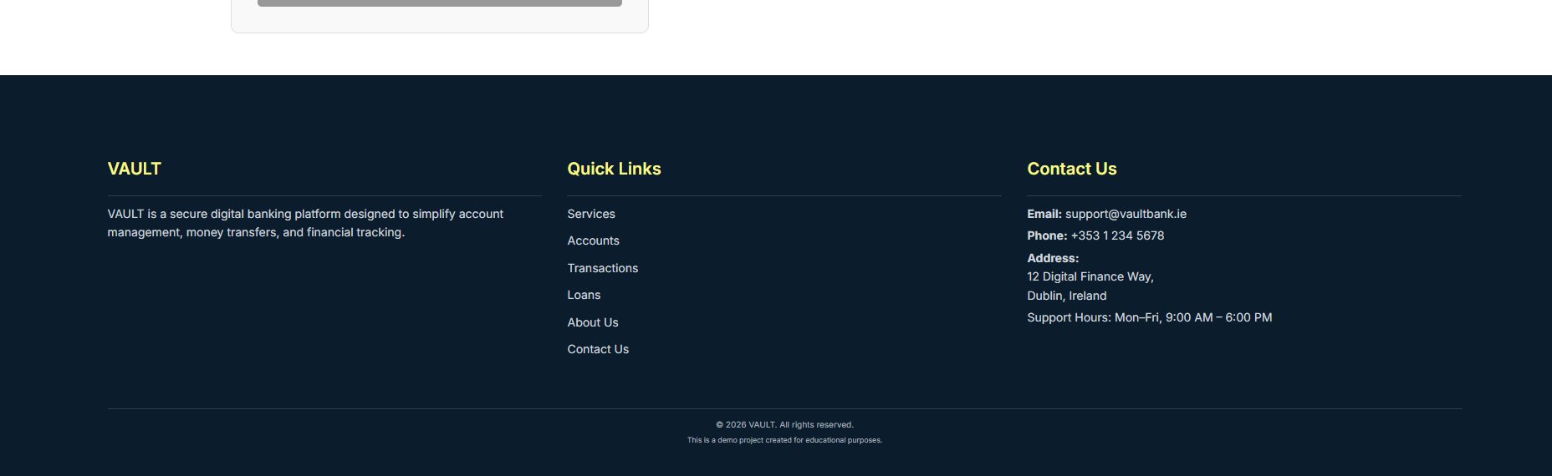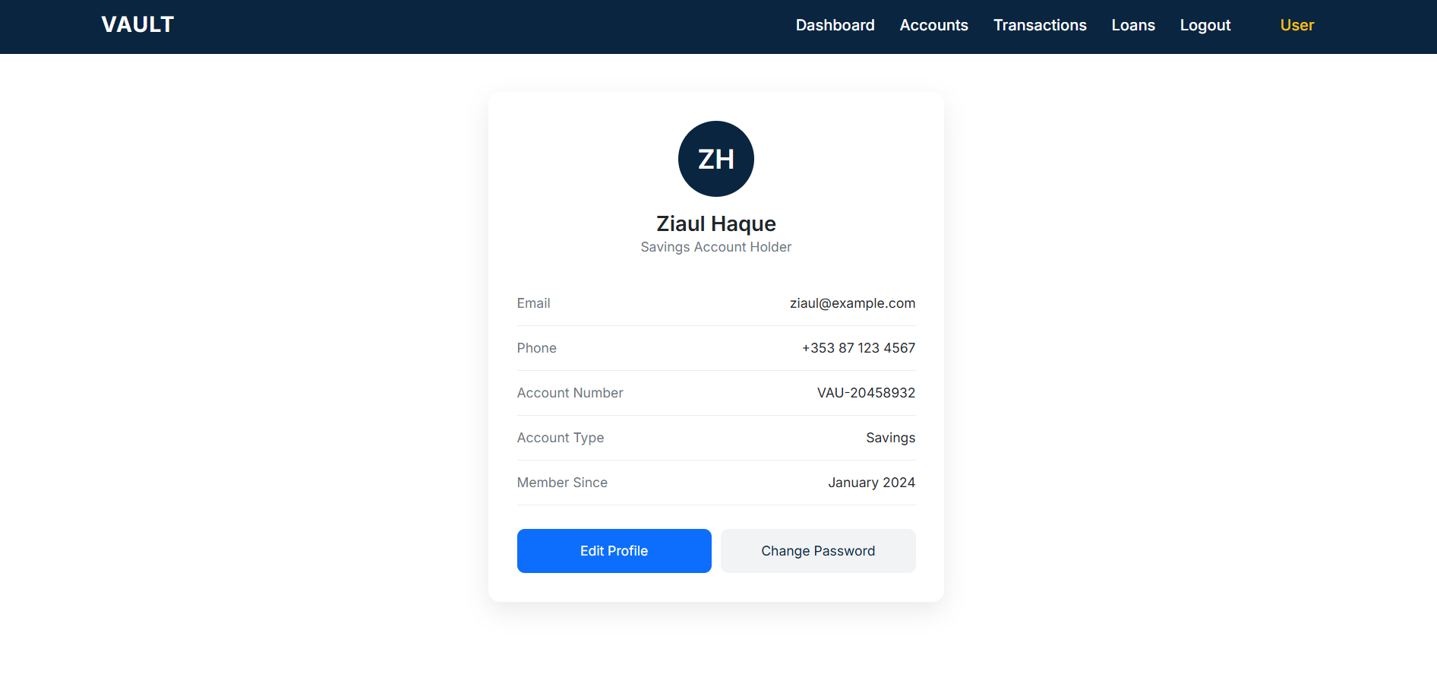

Purpose of the Application
The main purpose of this project is to:
- Demonstrate understanding of different web application types, specifically a financial/banking system
- Showcase effective information presentation and collection
- Apply best practices in HTML structure, semantic elements, and CSS styling
- Design a clean, easy-to-navigate interface suitable for all platforms

Application Features
The Vault Bank web application includes the following static client-side pages:
- Homepage (index.html): Introduction to the application with branding and navigation
- Login & Registration Pages: User authentication interfaces (front-end only)
- Dashboard: Overview and Landing page after login
- Accounts Page: Displays bank accounts using demo data, back-end implantation required
- Transactions Page: Lists demo transaction history with a link to transfer funds
- Transfer Page: Static money transfer form
- Loans Page: Displays available loan options and a demo loan application form
- Profile Page: Displays user profile information
All data displayed is demonstration data only.

Technologies Used

HTML
- Forms, tables, lists, and input controls
- Proper document structure and accessibility-friendly markup

CSS
- Global styles and page-specific CSS files
- Layout design using spacing, alignment, and responsive principles
- Typography and color schemes suitable for a banking application
Bootstrap
- Use of Bootstrap 5 framework to speed up layout and responsive design
- Predefined grid system (container, row, col-*) for structured page layouts
- Bootstrap components such as navigation bars, forms, buttons, cards, and utilities
- Custom CSS layered on top of Bootstrap to maintain a consistent banking theme

Design Approach
The user interface was designed with simplicity and clarity in mind. A consistent navigation bar and footer are used across pages to ensure ease of navigation. Multiple CSS files were created to improve maintainability and scalability, separating global styles from authentication, forms, and page-specific layouts.
All files are linked using relative paths to ensure the application works correctly across different platforms.

Assignment Compliance
This project strictly follows Assignment 1 requirements:
- Uses Bootstrap, HTML and CSS only
- No JavaScript or backend technologies
- Proper folder structure
- Commented code for clarity
- Expandable design for future assignments

Future Enhancements
In subsequent assignments, this application can be enhanced by:
- Adding server-side logic
- Implementing authentication and authorization
- Connecting to a database
- Making transactions and loans fully functional

Conclusion
The Vault Bank project demonstrates a solid understanding of client-side web development concepts covered in Lectures 1 and 2. It provides a realistic, well-structured foundation for further development throughout the semester.

